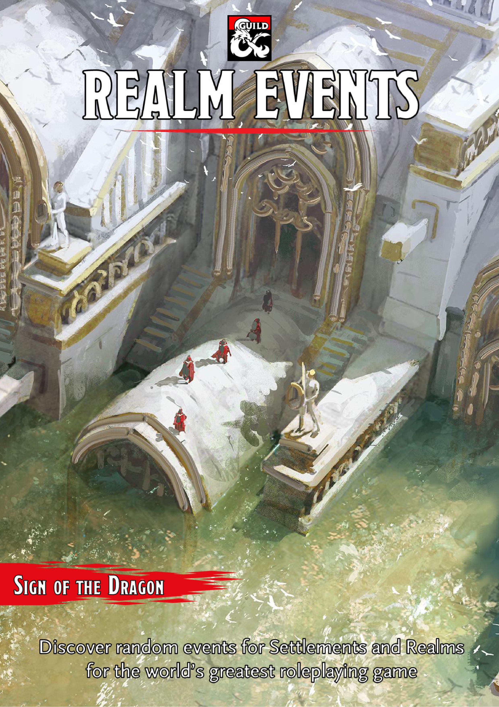

Introduction

11 too often, we forget that the world spins on around the adventurers and their quests. That I |[ world is full of vibrant life and events that can = ■ impact the adventurers’ life.

This book is written for those who love random events and encounters.

Cheers,

***Sign of the Dragon***

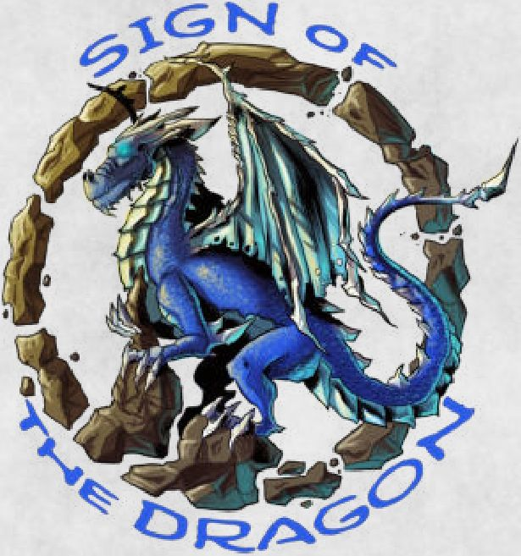

On the Cover

Massive flooding devastates the realm. Will the characters use their power to save the day or to save themselves?

Credits

**Lead Designer:** Marco Fossati

**Writer:** Marco Fossati

**Art Director:** Marco Bertini

**Graphic Designer and Layout:** Marco Bertini

**Editor:** Daniel Chivers

**Cover Art:** Leonardo Borazio

**Internal Art:** Bruno Balixa; Daniel Comerci - danielcomerci.com; Forrest ImeL Some artwork © 2015 Dean Spencer, used with permission. All rights reserved The Dungeon Masters Guild was used as a source for some of the art. All art taken from there is owned by Wizards of the Coast and is used with permission under the Community Content Agreement for the Dungeon Masters Guild

**Special Thanks to:** Venti di Ruolo, Alessio Annaloro, Alessandro Fierro, Andrea Caramia

Overview

This book was written to help DMs add depth to their campaign worlds. Specifically, this volume gives DMs the chance to quickly create events and encounters in villages, towns, and cities. This will be especially helpful when the characters go off script and end up in an area that the DM has not fleshed out at all

The book contains the following chapters:

Chapter **1:** Settlement Events Chapter **2:** Regional Events Chapter **3: How** to Use the Events

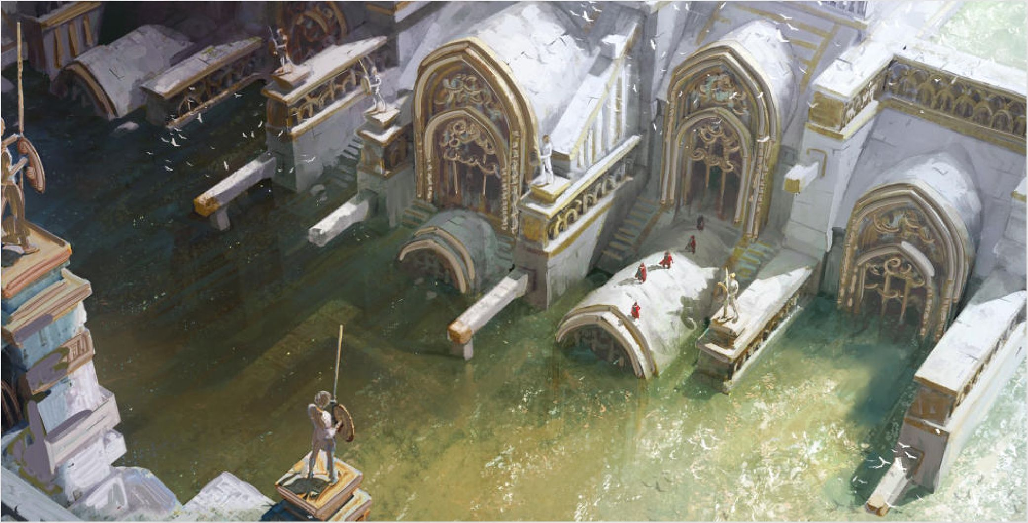

*DUNGEONS & DRAGONS, D&D, Wizards of the Coast, Forgotten Realms, Ravenloft, Eberron, the dragon ampersand, Ravnica and all other Wizards of the Coast product names, and their respective logos are trademarks of Wizards of the Coast in the USA and other countries. This work contains material that is copyright Wizards of the Coast and/or other authors. Such material is used with permission under the Community Content Agreement for Dungeon Masters Guild*

*All other original material in this work is copyright 2020 by* ***Marco Bertini*** *and* ***Marco Fossati*** *and published under the Community Content Agreement for Dungeon Masters Guild*

Contents

Introduction and Credits **2**

Chapter **1:** Settlement Events **4**

Bard 4

Birth, Minor 4

Bridge 5

Canal 5

Carnival/ Circus 5

Collapse 5

Death, Minor 6

Drowning 6

Enemy Killed/Captured 6

Execution 6

Fair 6

Faith Gathering 7

Fire, Minor 7

Flooding, Minor 7

Gladiatorial Games 7

Kidnapping, Minor 7

Holiday 7

Holy Relic 7

Holy Person 8

Local Hero 8

Mage Fair 9

Marriage, Minor 9

Murder Attempt 9

Opening 9

Press Gang 10

Protector Leaves 10

Public Punishment 10

Races/Games 10

Raid 10

Sage 11

Search 11

Tax Collection 11

Theft 11

Troop Movement 11

Tribute Due 11

Undead 12

Wall/Moat 12

Chapter **2:** Regional Events **14**

Ambassador 14

Assassination of a Lord or Lady 14

Birth, Major 14

Comet 15

Death of a Lord or Lady 15

Earthquake 15

Famine 15

Fire, Major 15

Flooding, Major 15

Incursion 15

Marriage, Major 16

Plague 16

Political Plot 16

Rebellion 16

Religious Matter 16

Visitation 17

Volcano 17

War 18

Chapter **3: How** to Use the **20**

Events

Frequency 20

New NPCs and Plots 20

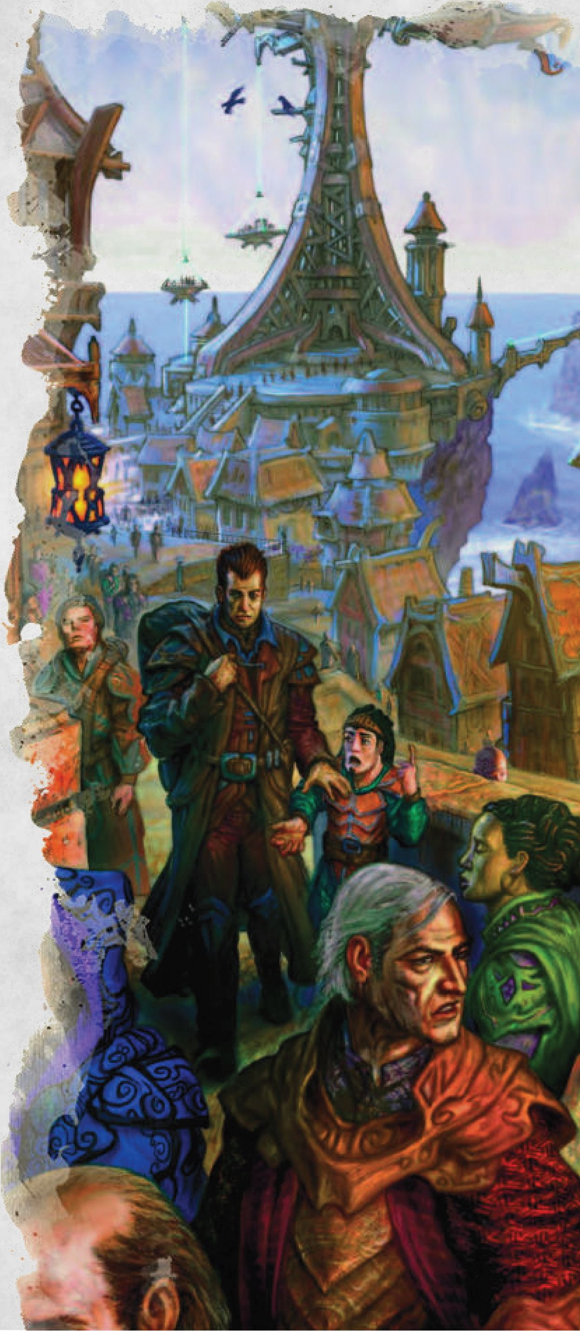

Chapter 1: Settlement Events

he tables in this chapter describe the events ~ that can occur in a village, town, or city. You № 1 can randomly choose one of them or pick it

Local Events

|  |  |
| --- | --- |
| d100 | Event |
| 01-03 | Bard |
| 04-06 | Birth, minor |
| 07-08 | Bridge |
| 09-10 | Canal |
| 11-13 | Carnival/Circus |
| 14-16 | Collapse |
| 17-19 | Death, minor |
| 20-22 | Drowning |
| 23-25 | Enemy killed/captured |
| 26 | Execution |
| 27-29 | Fair |
| 30-32 | Faith gathering |
| 33-35 | Fire, minor |
| 36-38 | Flooding, minor |
| 39-41 | Gladiatorial games |
| 42-43 | Kidnapping, minor |
| 44-46 | Holiday |
| 47-48 | Holy relic |
| 49-51 | Holy person |
| 52-55 | Local hero |
| 56-57 | Mage fair |
| 58-60 | Marriage, minor |
| ||61-62 | Murder attempt |
| [jJ.63-64 | Opening |
| 65-66 | Press gang |
| 1^67-68 | Protector levies |
| 69-71 | Public punishment |
| 72-74 | Races/Games |
| 75-77 | Raid |
| 78-81 | Sage |
| 82-84 | Search |
| 85-87 | Tax collection |
| 88-90 | Theft |
| 91-92 | Troop movement |
| 93-95 | Tribute due |
| 96-98 | Undead |
| 99-00 | Wall/Moat |

Bard

A famous bard is visiting the town. It might be a masterful performer or one renown for their scandalous topics.

***What the characters can do.*** The table below presents some possible side-quests for this event.

Bard Event

d6 Side-Quests

1. The bard is a rival of one of the characters*
2. One of the bard's songs is related to an item or person the characters are looking for
3. The bard has received death threats. They want to hire the characters as guards
4. The bard is known to own a very rare magical instrument**
5. The bard inadvertently summons some fiends
6. The bard has a rival that wants to ruin the performance. The characters may be hired by either party.

As described in *Xanathar’s Guide to Everything. \**

*Vault of Magic* II has a collection of magical instruments: [https://www.dmsguildcom/product/301161](https://www.dmsguild.com/product/301161). **

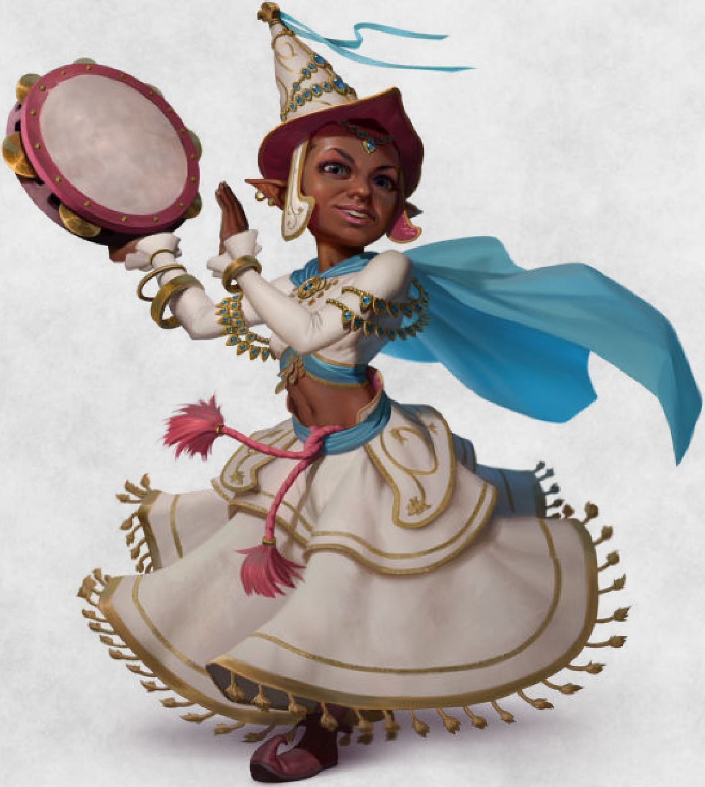

Birth, Minor

The arrival of a child is always a happy event. The newborn might be the whelp of a minor noble house, a wealthy merchant, or a commoner of some renown.

***What the characters can do.*** This event can lead to side quests in the future. The birth may have changed the status of the previous heir, such as an older illegitimate son, or maybe the newborn might be illegitimate. In some cases, there could be speculations about the paternity of that child, especially if the father is often absent or very old A member of the family can hire the characters to prove or disprove the rightfulness of the birth, or to protect the baby from kidnapping or murder.

•

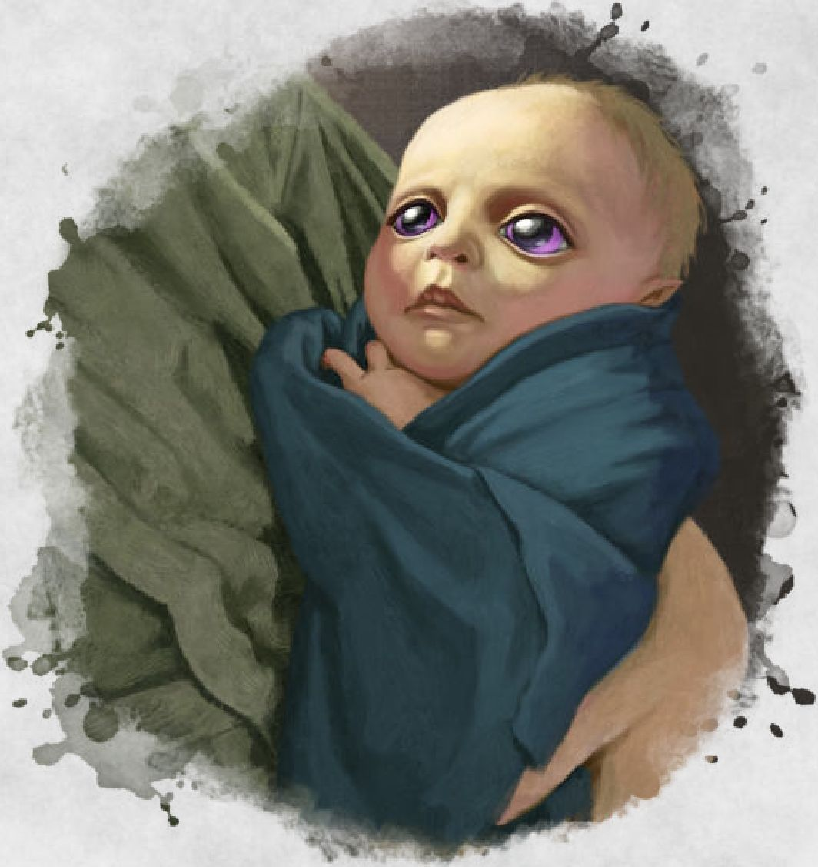

Bridge

A new bridge is being built across a river. It could be a replacement for an old one or entirely new. Workers can either be hired workers, conscripts, or slaves according to the local culture and laws.

***What the characters can do.*** The table below presents some possible side-quests for this event.

■

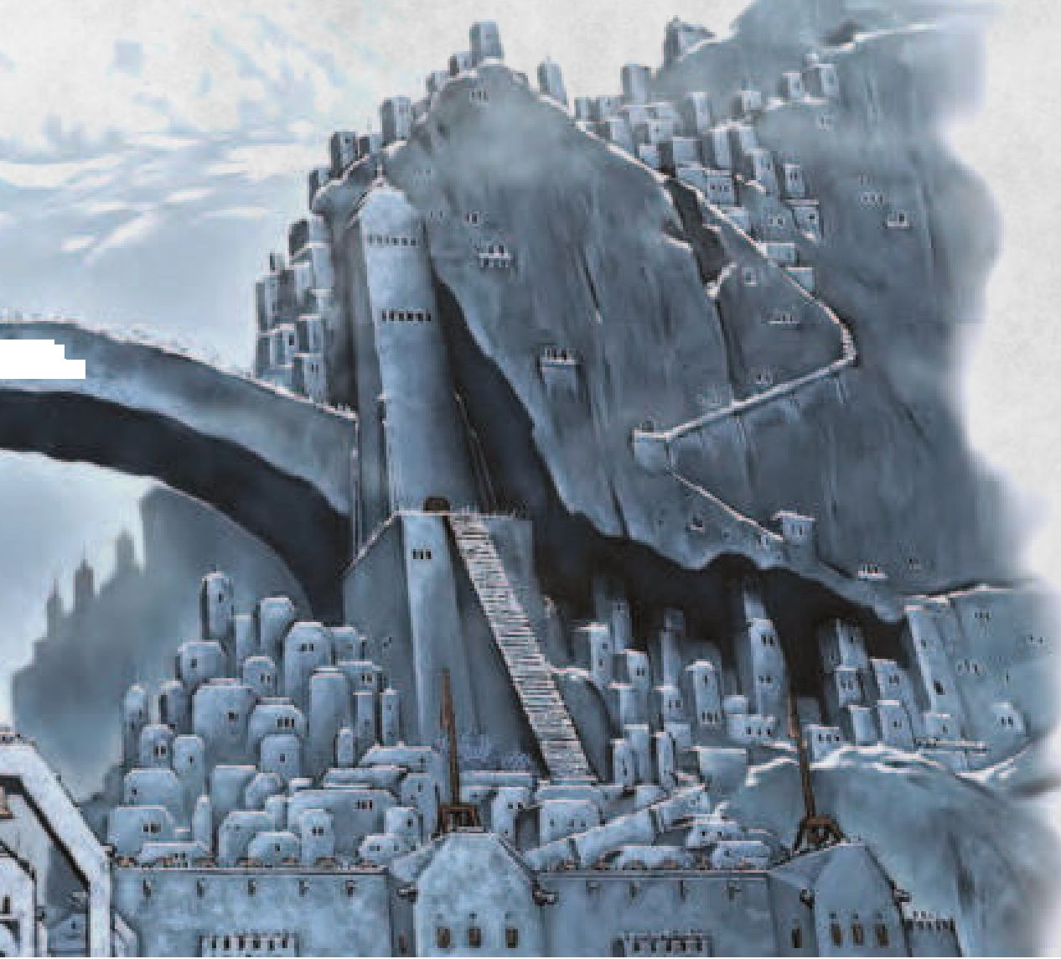

Bridge Event

d4 Side-Quests

1. The Characters are hired to quell a worker strike or rebellion
2. A member of the local government asks the characters for funds to complete the bridge
3. Characters are hired to escort the envoy that is sent to obtain the grant to build the bridge
4. Characters are hired to clear the area from hostile groups, such as goblins or underwater races

Canal

A canal is being built to bring fresh water to people and fields.

***What the characters can do.*** The table below presents some possible side-quests for this event.

Canal Event

d4 Side-Quests

1. The Characters are asked to use magic to help with construction
2. A member of the local government asks the characters for funds to complete the canal
3. Characters are asked to help dig the canal
4. Characters are hired to clear the area of hostile groups or monsters

CarnivalCircus

A circus or some other travelling show is coming to town. There will be shows and other amusements for a week or more.

***What the characters can do.*** The table below presents some possible side-quests for this event.

Carnival/Circus Event

d6 Side-Quests

1. A rival of one of the characters has arrived to attend the circus*
2. The Characters meet one or more old friends of theirs
3. Monsters flee from the circus. The characters must retrieve them
4. A thief steals a valuable item - even a magic one - off one of the characters
5. Local government suspects there is a spy among the members of the carnival. Characters are hired to find the truth
6. A fortune teller knows exactly who the characters are and what their immediate goals are

As described in *Xanathar’s Guide to Everything. \**

Collapse

A building or a structure collapses, causing little to no casualties.

Collapse

d6 Building

1. Bridge
2. Dam

|  |  |
| --- | --- |
| d6 | Building |
| 3 | Dock |
| 4 | Outer wall |
| 5 | Private house |
| 6 | Tower |
| 7 | Temple |
| 8 | Public building |

***What the characters can do.*** Characters might be involved in rescuing survivors from the ruins or they might be hired to investigate the causes of the collapse.

Death, Minor

Someone important has died of seemingly natural causes. They might be an ally of the characters, a friend, or someone they don’t know. If the dead was a person of renown, then there is a public ceremony.

***What the characters can do.*** The characters could attend the funeral, bringing condolences to the relatives, or maybe they could discover they are on the will and have inherited something of value.

Drowning

Someone has drowned

***What the characters can do.*** The characters can help search for the body or they can investigate why the person drowned

Enemy Killed/Captured

An enemy of the local people is killed or captured The following tables give you suggestions for the type of enemy and the organization that killed or captured them.

Enemy

d8 Enemies

1. Bandit captain
2. Rival of one of the characters*
3. Huge beast
4. Goblinoid/Orc chieftain
5. Officer of an enemy army
6. Monstrosity
7. Aberration
8. Minor fiend

As described in *Xanathar’s Guide to Everything. \**

Organization

d6 Organizations

1. Local law renforcement
2. Rival of one of the characters*
3. Regular army
4. Mercenary unit
5. Adventurers
6. Local militia

As described in *Xanathar’s Guide to Everything. \**

***What the characters can do.*** The enemy might be one that the characters were also looking for. They might be hired to clean up surviving minions or, if the enemy was captured the characters could help with the interrogation

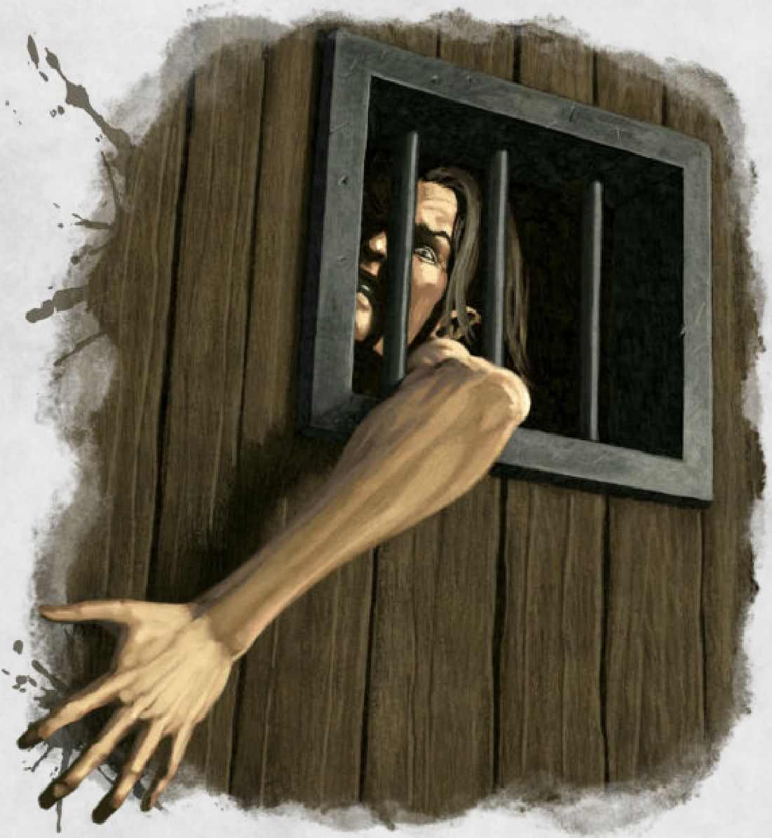

Execution

A court, a judge, or a magistrate has sentenced someone to die. The execution could use any means of death, from the historic to the fantastical, depending on your campaign and what your players can handle. The executed can be an enemy of the characters, a stranger, or even an old acquaintance of theirs.

***What the characters can do.*** The characters can watch the event or be hired by local law enforcement to prevent any attempt to free the person. They can also try and rescue the condemned

Fair

A fair is coming to town. It can be either seasonal or travelling. The table below gives you some suggestions.

Fair's Topic

d8 Topics

1. Exotic beasts
2. Weapons and armors
3. Agricultural products
4. Horses
5. Beasts of burdens
6. Trinkets
7. Tools
8. Adventurers’ gear

***What the characters can do.*** The characters can take part in the fair or buy and sell goods. They can also participatein the festivities. They can have fun, relax, and meet new and old friends or rivals.

Faith Gathering

A religious meeting is being held in the nearest settlement. People from near and far are coming to attend important holy rites.

***What the characters can do.*** If the characters are followers of that faith, they should attend the gathering. Priests of that faith can provide advice or spells and listen to the pleas of the faithful or the characters.

Fire, Minor

A nearby building in on fire.

***What the characters can do.*** The characters can rescue someone trapped inside, fight the fire, or be hired to investigate the causes of the fire.

Flooding, Minor

Excessive rain has turned the roads and fields surrounding a settlement into a mess of mud and high water.

***What the characters can do.*** Travel through the flooded area will be difficult. The terrain is difficult or can only be moved through by swimming.

Gladiatorial Games

Fight matches are being held in town. According to the local laws, the fight can be public or hidden. Winners are regarded as heros by the common folk, at least until a new winner steps up. The table below suggests types of games.

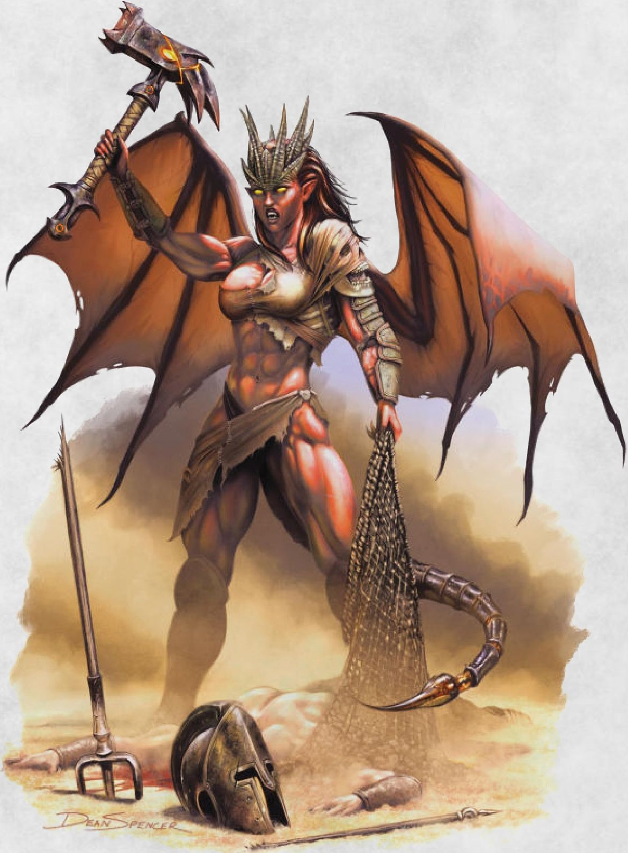

***What the characters can do.*** The characters can attend the games, bet on a participant, or join the games themselves.

Kidnapping, Minor

Someone has been taken away and is being held for ransom.

***What the characters can do.*** The table below presents some possible side-quests for this event.

Kidnapping Event

d6 Side-Quests

1. Relatives of the captive ask the characters for help with the ransom
2. Characters are tasked to collect the ransom money
3. Characters are hired to locate the captive and free them
4. Characters are tasked to oversee the transfer of money
5. Characters are hired to hunt down the kidnappers and deal with them. The kidnapped’s survival may or may not be important.
6. Characters are asked by the kidnapper to get in touch with the relatives of the captive

Holiday

A holiday is being held in the city. It could be annual, or a spontaneous event commanded by a local authority to celebrate something that has just happened The table below gives you suggestions about the type of holiday.

Types of Holiday

d8 Holiday

1. Agricultural event
2. Ancient battle won
3. Arrival of a famous hero
4. Founding of the settlement
5. Religious
6. Marriage or childbirth
7. End of a war
8. Visit of a foreign ruler

Holy Relic

A holy relic is taken on tour to be shown to followers. It is important to the faithful and is either magical or non- magical The relic is escorted by guards, low-level acolytes, and at least a senior priest of the faith. The table below suggest you some types of relics.

Types of Relic

d8 Relic

1. Bones of a martyr
2. Ancient weapon
3. Religious banner
4. Robe worn by a saint
5. Sacred texts
6. Book of sacred rites

d8 Relic

1. Item belonging to the founder
2. Divine or infernal jewelry

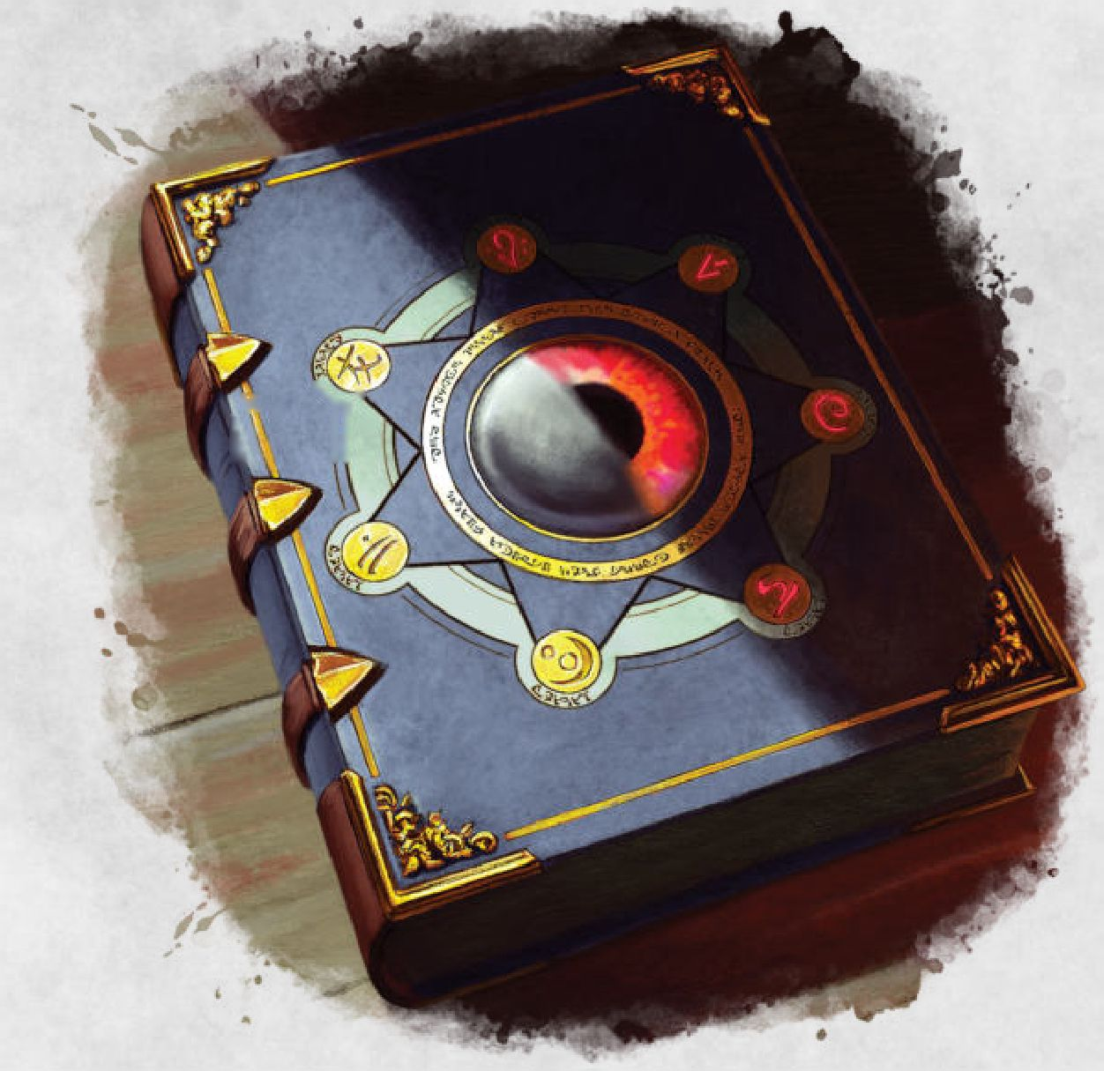

|  |  |
| --- | --- |
|  | V. ''S’ |
|  | L 11 |
|  |  |

***What the characters can do.*** The table below presents some possible side-quests for this event.

Holy Relic Event

d6 Side-Quests

1. The priests hire the characters as additional guards to prevent a theft
2. A rival cult manages to steal the relic and the characters are tasked to find and bring it back
3. Characters discover the relic is a fake
4. Characters discover the relic has lost its magical powers
5. Characters discover the relic has gained magical powers
6. A rival priesthood hires the characters to steal or destroy the relic

Holy Person

A venerated person of faith is visiting the city. People come from neighboring cities to visit, looking for counsel, or just to hear them speak. The table below can be used to determine who the holy person is.

Types of Holy Person

d8 Holy Man

1. A celestial
2. A very pious old woman
3. A high priest
4. A hermit

d8 Holy Man

1. A strong warrior of faith
2. A renowned scholar of the faith's sacred texts
3. A simple man that can make miracles
4. A person that claims to have in their veins blood of the god itself

***What the characters can do.*** The characters can meet the holy person and possibly gain a new ally for the future.

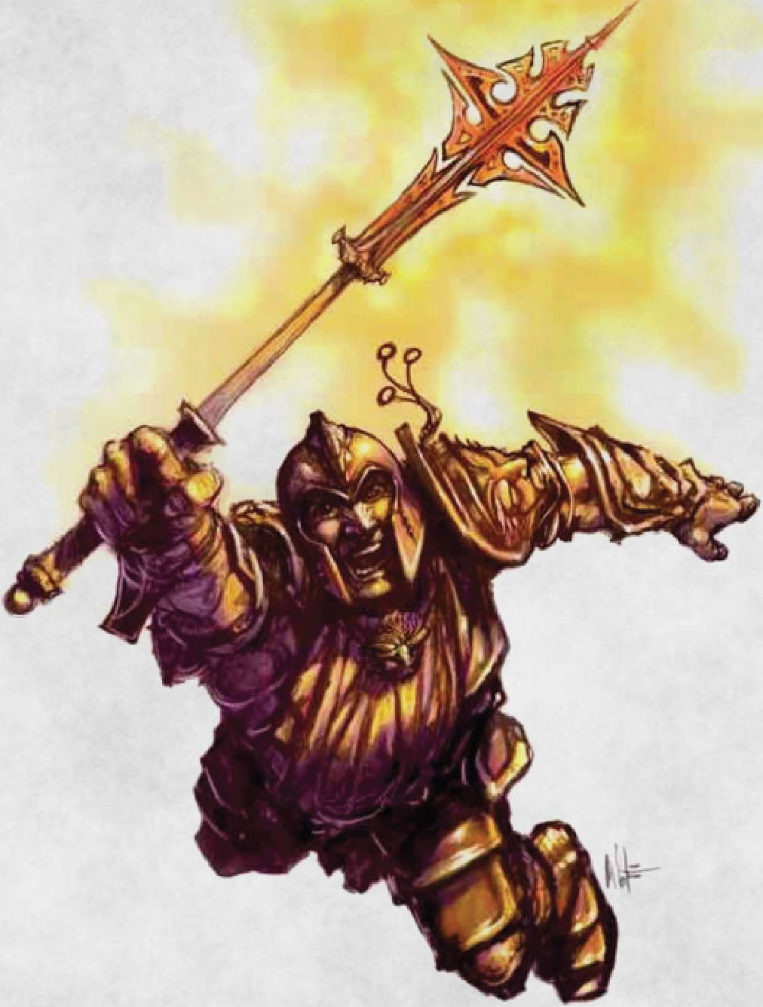

Local Hero

A famous adventurer is returning to their hometown. They saved the town in the past, or at least common folk think they did Or maybe they gained fame and glory while adventuring far from home.

***What the characters can do.***

The table below presents some possible side-quests for this event.

Local Hero Event

d6 Side-Quests

1. The hero has clues about the characters' current quest
2. The characters discover that the hero is a fraud
3. The characters discover that the hero is secretly a member of a dark cult
4. The characters are hired to steal a magic item owned by the hero

d6 Side-Quests

1. The hero is looking for companions for their next quest
2. The hero is not welcomed by local authority. The characters are asked to arrest them

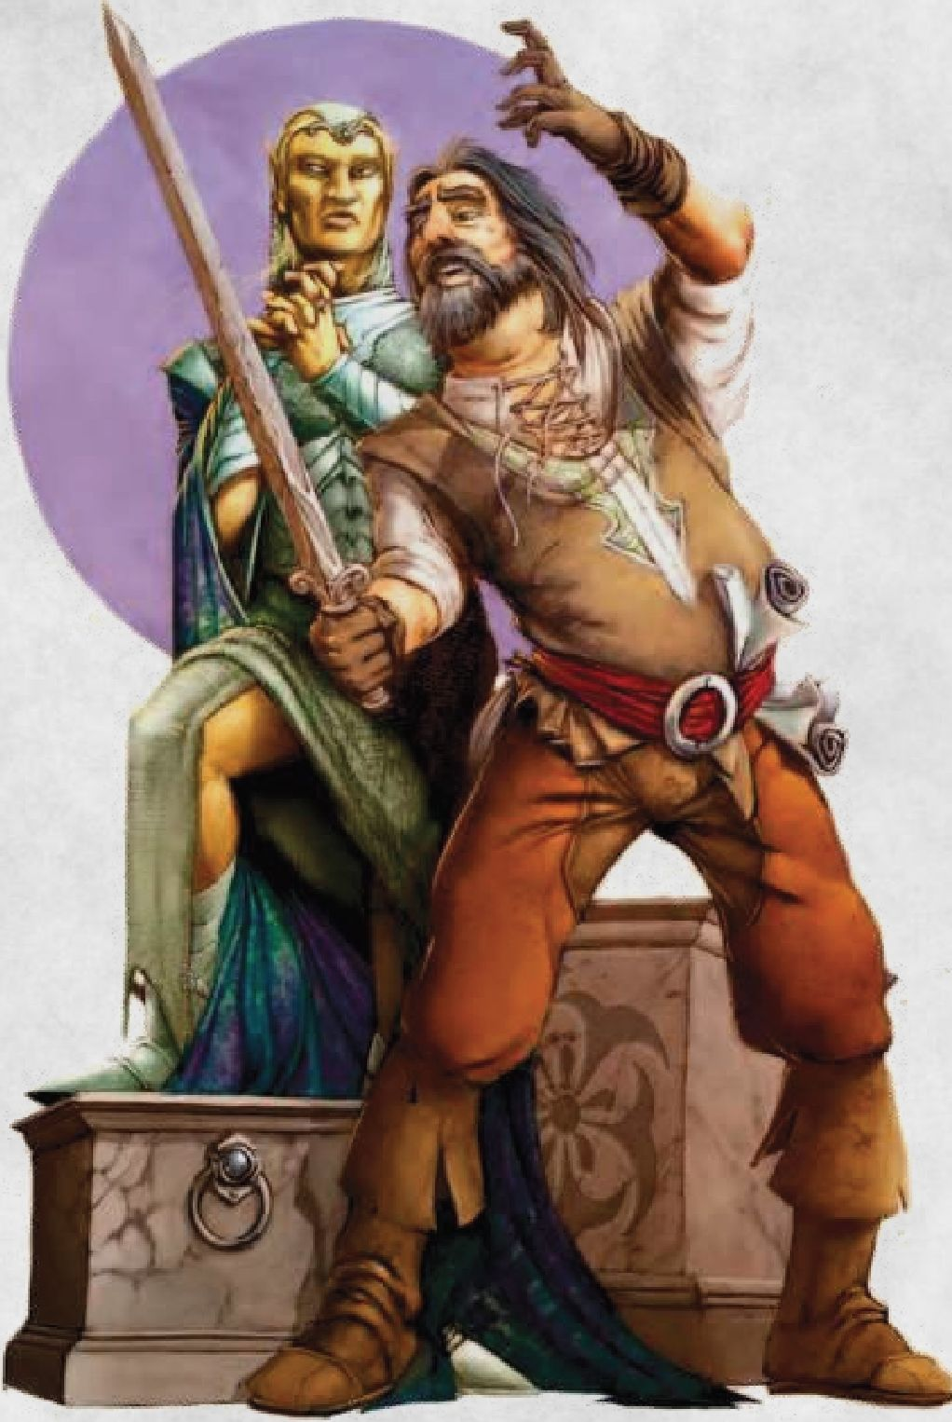

d6 Side-Quests

1. Someone hires the characters to steal a precious magic item

Marriage, Minor

Someone is getting married. The couple might be part of a minor noble house, scions of wealthy merchant house, or commoners of some renown.

***What the characters can do.*** The characters can take part in the wedding. They might also be honored guests.

Murder Attempt

A dweller of some renown has been the victim of a murder attempt that leaves that person heavily wounded or close to death.

***What the characters can do.*** The characters can be asked to find the assassin and determined who hired them. Or the characters may be accused of being the assassins. In this case they must prove their innocence while being chased by the law or mercenaries hired by the victim.

Opening

A new structure is opening. The table below gives you a list of possible buildings.

Structures

d8 Building

1. Town Hall
2. Temple
3. Library
4. School
5. Hospital
6. Tavern/Inn
7. Feasthall

Mage Fair

A mage fair is being held in the settlement. Mages from all the surrounding areas come to the settlement, to exchange items, news, and to share their research or show off new spells.

***What the characters can do.*** The characters can take part in the fair, buy and sell magic items, or take downtime activities. They can have fun, relax, and meet new and old friends or rivals. The table below presents some possible side-quests for this event.

Mage Fair Event

d6 Side-Quests

1. A mage duel begins. The characters are asked to be the referees, stop the mages, or even to take part in the duel
2. A mage has lost control of a conjured demon. The characters must stop it
3. Characters are tasked to prevent thefts of valuable magic items
4. A mage attending the fair is a spy or a member of a dark cult. The characters must find them
5. A magic item of the characters has been stolen during the fair and they must retrieve it
6. Shop

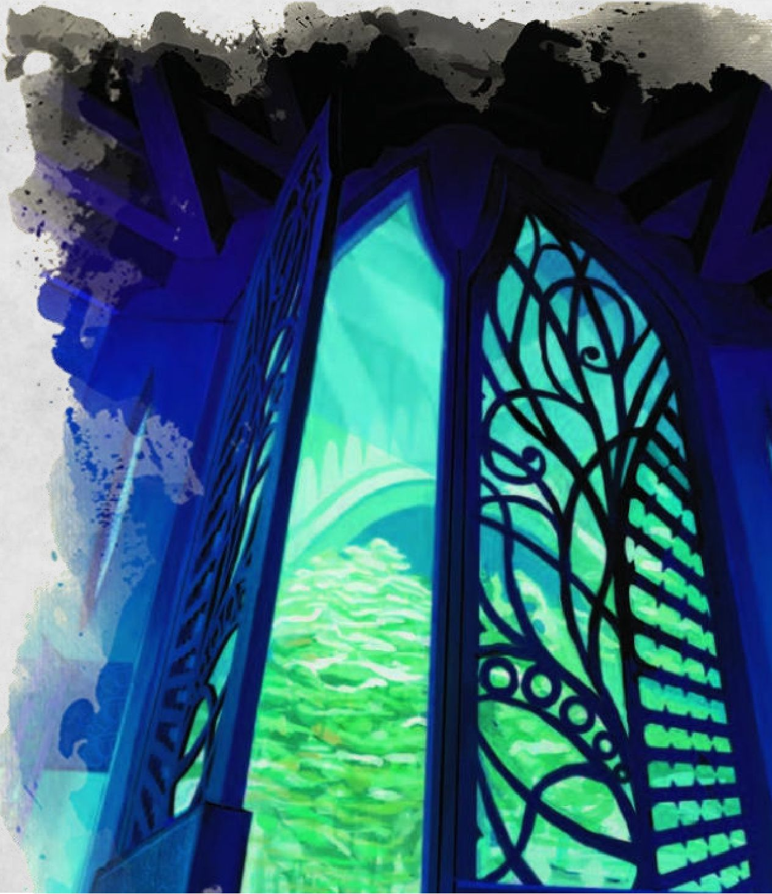

***What the characters can do.*** The characters can fund the opening of the structure and take downtime activities there.

Press Gang

By using force, a group is recruiting people for induction into the army or navy.

***What the characters can do.*** The table below presents some possible side-quests for this event.

Press Gang Event

d6 Side-Quests

1. The characters are targeted by the press gang by accident
2. A local noble asks the characters to stop the press gang
3. The characters are hired to support the press gang
4. Someone hires the characters to free a relative caught by the press gang
5. The press gang is led by a rival of the characters. Their real aim is to kidnap the characters
6. The press gang kills the son of a wealthy merchant by accident, who then hires the characters for revenge

Protector Leaves

A protector of the town leaves or is killed This protector could be a wide variety of things, as shown in the table below.

|  |  |
| --- | --- |
| Protectors | |
| d8 | Protector |
| 1 | Sheriff |
| 2 | Nobleman |
| 3 | Druid |
| 4 | Wizard |
| 5 | Dragon |
| ^‘6 | Rangers |
| 7 | Knights |
| 8 | Fey creature |

***What the characters can do.*** While the protector is absent, the characters can be asked to protect the town until a substitute is found

Public Punishment

A criminal is being punished in the city. He might be a thief, a smuggler, or another petty criminal A little crowd is gathering to attend the punishment.

***What the characters can do.***

The characters can just watch the event or be hired by local law enforcement to prevent any attempt to free the person, or they can attempt a rescue.

Races/Games

Games are being held Winners are regarded as heroes by common folk, at least until a new winner is decided The table below suggests some types of games.

Types of Games

d6 Games

1. Horse racing
2. Beast racing
3. Chariot racing
4. Running
5. Stone throwing
6. Archery

***What the characters can do.*** The characters can attend the games, bet on a participant, or join the games themselves.

Raid

Outlying farms or the settlement is being attacked by organized groups. The table below gives you some examples of suitable groups.

Group

d8 Group

1. Goblinoid or kobold warband
2. Bandits
3. Rebels
4. Monstrosity
5. Enemy army
6. Gnolls
7. Orc warband
8. Giants

***What the characters can do.*** The table below presents some possible side quests for this event.

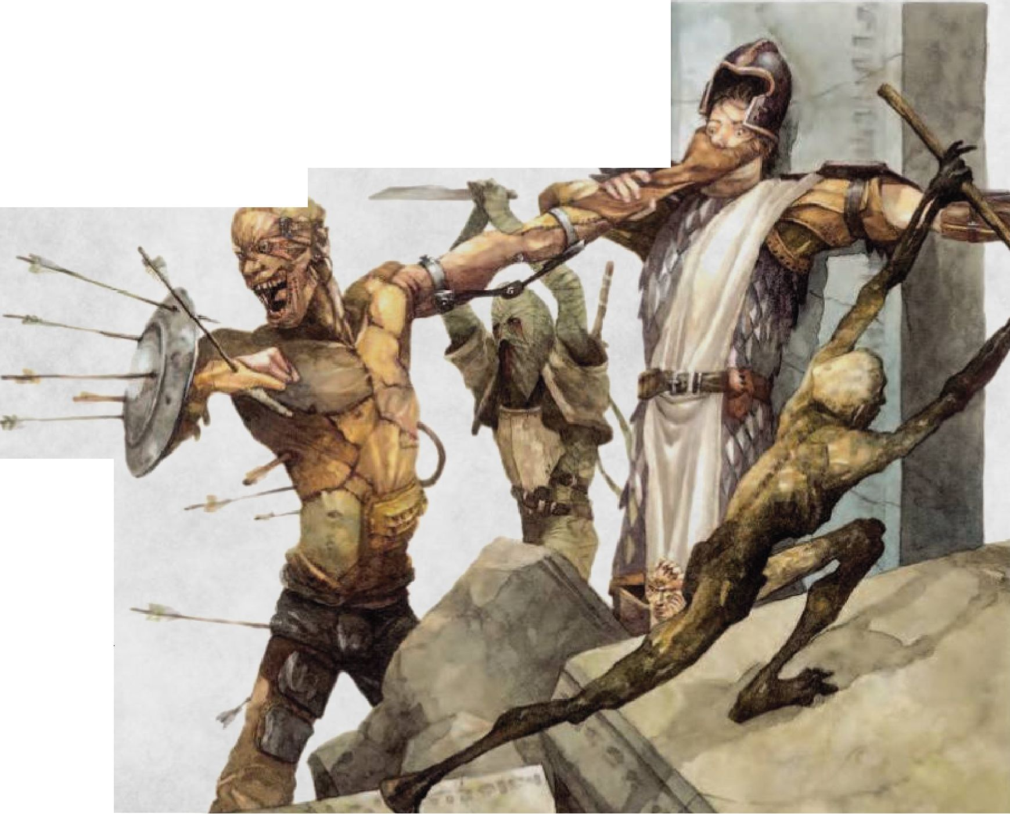

Raid Event

d6 Side-Quests

1. The characters are tasked to make a retaliatory strike
2. The characters must free some prisoner taken during the raid
3. The characters must retrieve some valuable items stolen during the raid
4. The characters must strengthen the town's defenses in preparation for a new attack
5. The attack seems unusual. The characters must investigate the real reasons behind it
6. The characters are sent to look for help from neighboring cities

Sage

A sage or a scholar of some field of study is visiting the settlement for research, a lecture, or personal matters.

***What the characters can do.*** The characters can meet the sage, request information, and possibly gain a new ally.

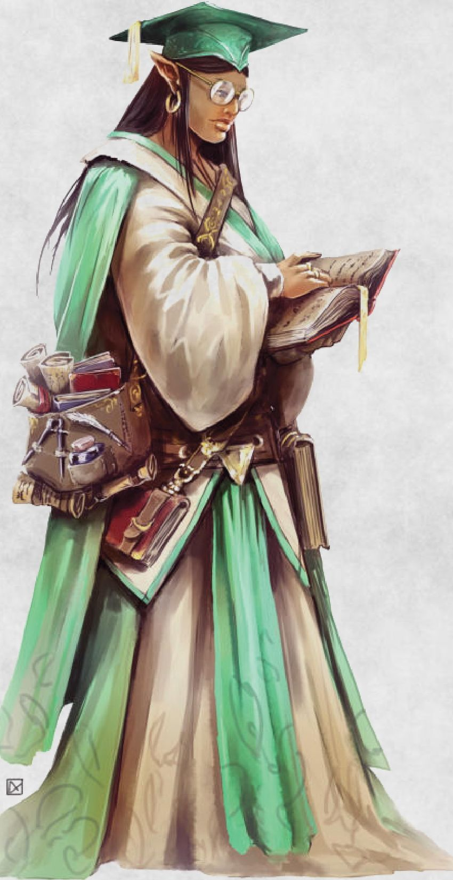

Search

A group of citizens or guards are searching for something or someone. The following table gives you some examples of the search target.

Search Target

d6 Target

1. A stolen item
2. An escaped prisoner
3. A suspected criminal
4. A rumored lycanthrope
5. A runaway beast
6. A spy

***What the characters can do.*** The characters can join the group, help in the search,or may be involved in hiding the fugitive.

Tax Collection

A regular or a specific tax is being collected in the settlement. The characters may have to pay the tax too.

***What the characters can do.*** The characters can be hired to help collect the tax or to defend the collectors from angry mobs.

Theft

Something valuable, owned by an important dweller of the settlement, has been stolen and investigations have begun.

***What the characters can do.*** The characters can be hired to investigate the case, or to help the local constabulary.

They can also be on the list of suspects and must work hard to prove their innocence.

Troop Movement

A large military force is on the move.

***What the characters can do.*** The characters can be hired to be part of the army or to investigate the reasons behind that movement.

Tribute Due

Someone is demanding a tribute from the settlement to prevent an attack. Alternatively, the tribute is paid to a creature that acts as a benevolent guardian of the town. The tables below offer some suggestions for who’s demanding the tribute and what kind of tribute is requested

Tribute Claimant

|  |  |
| --- | --- |
| d8 | Claimant |
| 1 | Goblinoid warband |
| 2 | Bandits |
| 3 | Rebels |
| 4 | Dragon |
| 5 | Orc warband |
| 6 | Giants |
| 7 | Celestial |
| 8 | Monstrosity |

Type of Tribute

d6 Tribute

1. Gold and silver
2. Gems and valuable items

CHAPTER 1 | SETTLEMENT EVENTS

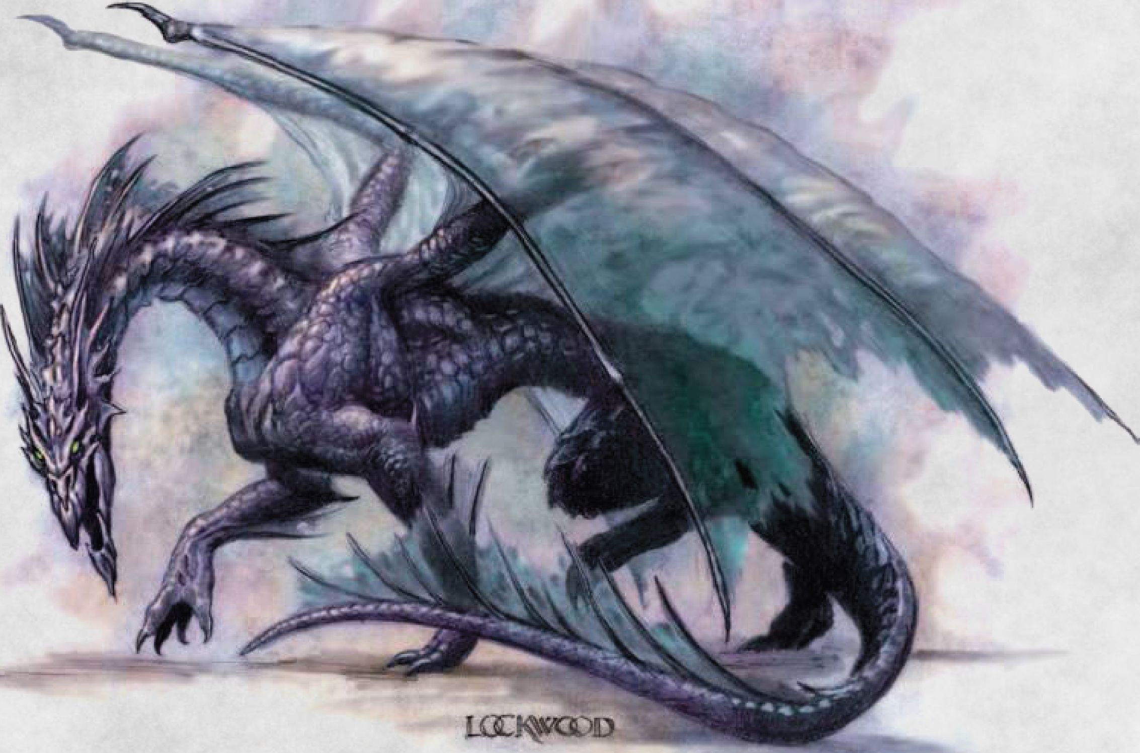

d6 Tribute

1. Livestock and food
2. Magic items
3. Slaves
4. A token, to prove subjugation

***What the characters can do.*** The characters can guard the tribute from some bandits, be charged to deliver it to its claimant, or they can be asked to drive off the city’s oppressor. In some cases, townspeople might ask them to contribute to the tribute.

Undead

Some undead are roaming the settlement or outskirts.

Type of Undead

d8 Undead

d8 Undead

1. Vampires

***What the characters can do.*** The characters can be hired to drive off the undead and to investigate what is behind their appearance.

WallMoat

The town is strengthening its defenses by building a wall or a moat. Alternatively, an old one is being repaired or modernized

***What the characters can do.***

The table below presents some possible side-quests for this event.

|  |  |
| --- | --- |
| 1 | Ghouls |
| 2 | Zombies |
| 3 | Skeletons |
| 4 | Wights |
| 5 | Wraiths |
| 6^ | Ghosts |
| 7 | Will-o'-Wisp |

CHAPTER 1 | SETTLEMENT EVENTS

Wall\Moat Event

d4 Side-Quests

1. The characters are asked to use magic to help with the construction
2. A member of the local government asks the characters for funds to complete the wall/moat
3. Characters are asked to help build the wall/moat
4. Characters are hired to clear the area of hostile groups or monsters

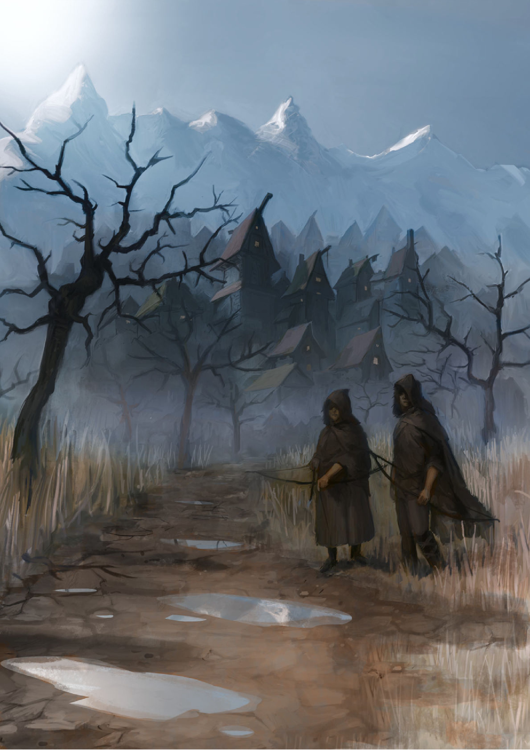

Chapter 2: Regional Events

he tables in this chapter describe the events that can occur in a larger area, such as a region or an entire realm. You can randomly choose one of them or pick one according to your campaign’s storyline.

Regional Events

d100 Events

01-10 Ambassador

11-13 Assassination of a lord or lady

14-18 Birth, major

19-21 Comet

22-26 Death of a lord or lady

27-30 Earthquake

31-40 Famine

41-45 Fire, major

46-50 Flooding, major

51-58 Incursion

59-6 3 Marriage, major

64-70 Plague

71-76 Political plot

77-79 Rebellion

80-84 Religious matter

85-88 Visitation

89-90 Volcano

91-00 War

Ambassador

An ambassador arrives from another realm. The ambassador’s goals can be determined randomly by using the following table.

Ambassador**'**s Goals

d6 Goals

1. To prevent or start a war
2. To form an alliance
3. To pay a tribute
4. To arrange a marriage
5. To promote trade
6. To experience the culture

***What the characters can do.*** The table below presents some possible side-quests for this event.

Ambassador Event

d6 Side-Quests

1. The characters are hired to guard the ambassador
2. The government suspects the ambassador is a spy and the characters must find proof
3. The characters must steal a rare magic item owned by the ambassador
4. The characters must meet the ambassador to gain safe passage to another realm
5. The characters must ruin the ambassador’s mission
6. Someone is trying to kidnap or kill the ambassador. The characters must prevent the assassination

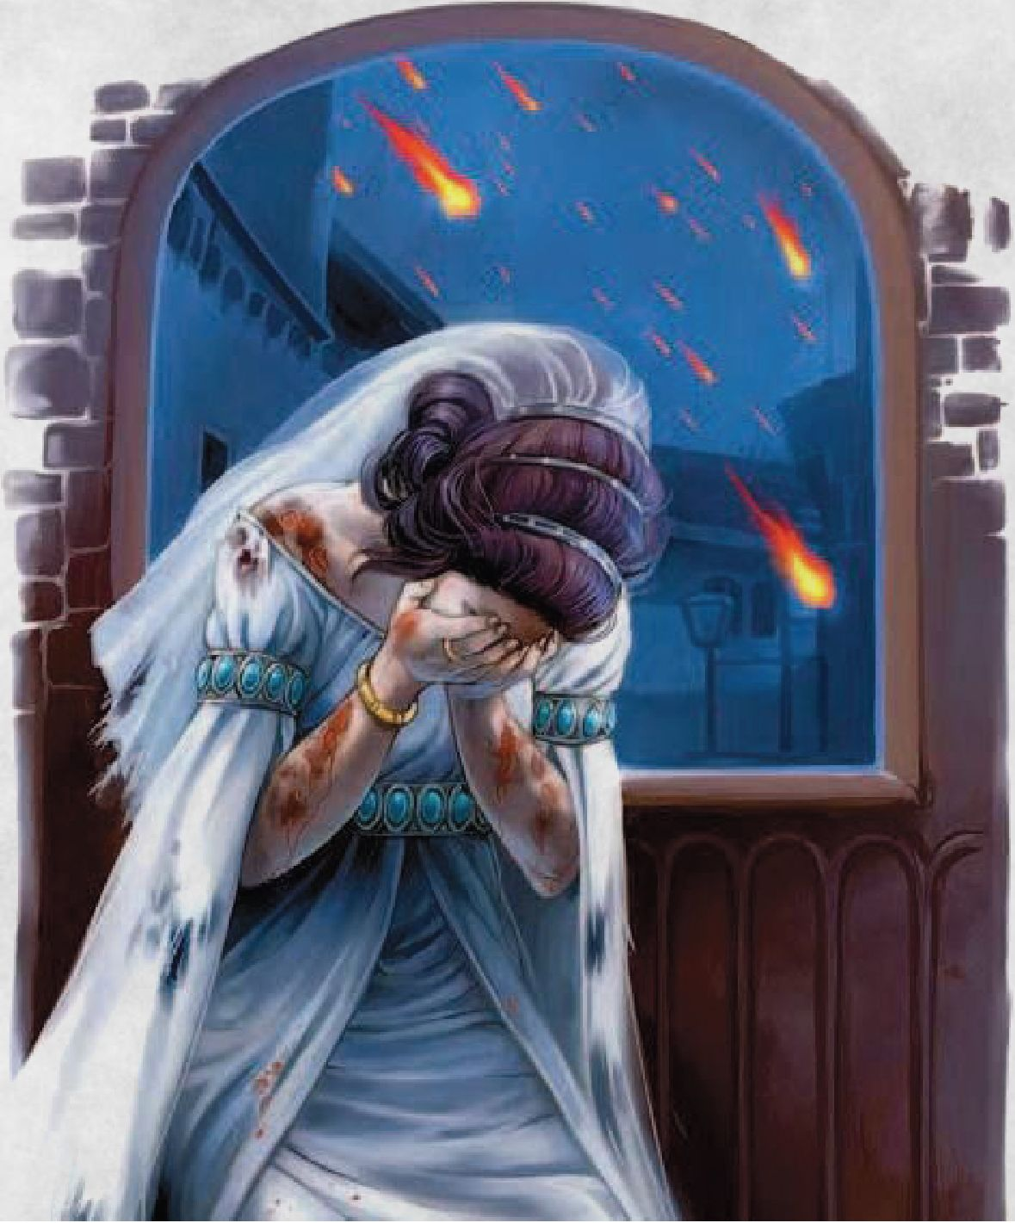

Assassination of a Lord or Lady

A high-ranking noble is assassinated Examples of lords and ladies are shown in the table below.

High Lords or Ladies

d6 Lords or Ladies

1. Ruler
2. Relative of the ruler
3. Member of a major noble house
4. High magistrate of the realm
5. High priest of a major faith of the realm
6. Wealthy guildmaster or merchant

***What the characters can do.*** The characters can be asked to investigate and find the murderer or discover who is behind the murder. Alternatively, they might be under suspicion and must work hard to prove their innocence. They might have a role in the following months of political turmoil too.

Birth, Major

A high-ranking noble's family has given birth to a child This is a cause for celebration for nobles and commoners alike. The event is a happy one and feasting and ceremonies last for several days.

***What the characters can do.*** This event can lead to side quests in the future. The birth may have changed the status of a previous heir, such as an older illegitimate son, or maybe the newborn might be illegitimate. In some cases, there could be speculations about the paternity of that children, especially if the father is often absent or very old A member of the family can hire the characters to prove or not the rightfulness of the birth, or to protect the baby from kidnappings or murder attempts.

Comet

A bright comet is sighted in the sky for ld4 weeks. It is seen as a portent of some great event.

***What the characters can do.*** The characters could be asked to find clues about the comet by finding sages, mediums, and diviners. Or they can search for ancient and hidden lore about the comet.

Death of a Lord or Lady

A high-ranking noble is dead Examples of lords and ladies are shown in the table below.

High Lords or Ladies

d6 Lords or Ladies

1. Ruler
2. Relative of the ruler
3. Member of a major noble house
4. High magistrate of the realm
5. High priest of a major faith of the realm
6. Wealthy guildmaster or merchant

***What the characters can do.*** The characters could be asked to investigate the causes of the death to find any possible evidence of some foul play. Alternatively, they might be under suspicion and must work hard to prove their innocence. They can have a role in the following months of political turmoil too.

Earthquake

A powerful earthquake strikes the realm. It causes extensive destruction in a 50-mile-radius area. It destroys cities and perhaps reshapes coastlines and rivers. It causes great fires in civilized areas followed by famine and plague.

***What the characters can do.*** The characters can guard the affected areas from monsters and bandits until law is restored They can also investigate if the earthquake was natural or supernatural.

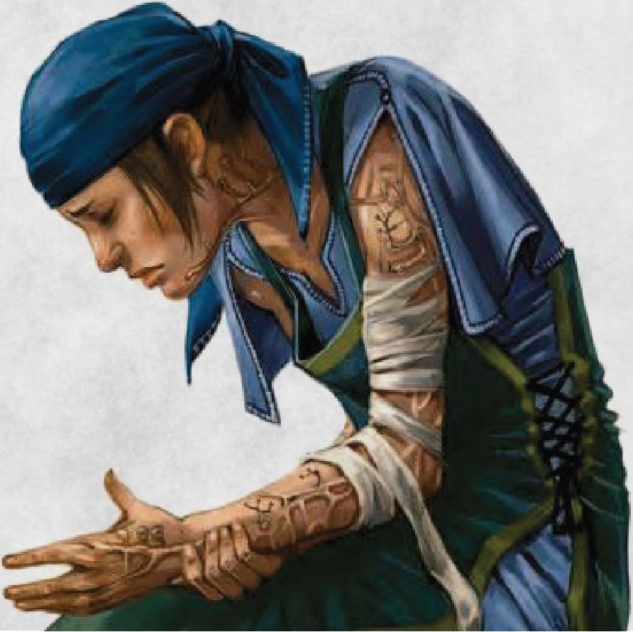

Famine

Drought and poor harvest result in famine. Possible signs of impending famine are withered crops, dead animals, hungry people, and the raising of food prices up to 10 times normal The famine lasts for 2d4 months.

***What the characters can do.*** The characters can guard granaries from bandits or oversee food distribution points. They can also investigate if the famine was natural or supernatural

Fire, Major

An extensive fire sweeps a major city of the realm and it destroys at least half of it.

***What the characters can do.*** The characters can rescue someone blocked inside, fight the fire, or be hired to investigate the causes of the fire.

Flooding, Major

A major flood sweeps the realm. If on the coast, severe storms cause heavy flooding along coastal regions. If along a river, a series of heavy rains cause the river to rage and overflow its banks.

***What the characters can do.*** Normal movement is impossible in flooded areas until the water recedes. They can also investigate if the flooding was natural or supernatural

Incursion

A major migration of creatures enters the realm from outside its borders. Although this migration is not war it is not necessarily peaceful The size of the incursion should be in proportion to the size of the realm. Thus, several hundred creatures would be a major incursion for a small province, while several thousand creatures would migrate into a large nation. The tables below give you some suggestions about the type of creatures and the reasons for their migration.

Type of Creatures

|  |  |
| --- | --- |
| d12 | Creatures |
| 1 | Elves |
| 2 | Goblinoids |
| 3 | Dwarves |
| 4 | Orcs |
| 5 | Humans |
|  | Giants |
| 7 | Troglodytes |
| 8 | Kobolds |
| 9 | Halflings |
| 10 | Dragonborns |
| 11 | Goliaths |
| 12 | Gnomes |

Reason of Migration

d6 Reasons

1. The group is fleeing an enemy attack
2. The group is trying to expand its territory

d6 Reasons

looking for a new homeland due the fall

1. The group is of its realm
2. The group is persecuted for its religious beliefs and is looking for a new home
3. The group is fleeing from a famine or a plague
4. The group is nomadic and wander from one place to an other one

***What the characters can do.*** The characters might investigate the reasons the group has entered the realm and take part in diplomatic talks. In addition, they can be asked to calm down tensions between the group and the people of the realm.

Marriage, Major

Someone is getting married The couple is part of a major noble house, they are scions of wealthy merchant house, or even the ruler of the realm might get married

***What the characters can do.*** The characters can take part in the wedding. They might be honored guests and meet old and new friends or rivals.

Plague

A terrible disease sweeps the realm for 2d6 months. Clerical spells aren’t enough to contain the plague and people fall ill and eventually die. When a plague strikes, the entire realm does not become diseased all at once. Rather, the plague moves about, sweeping from town to town bringing death and misery. Thus, a town may not yet have been hit by the plague, may currently be in the throes of the disaster, or may have suffered and survived through it already.

***What the characters can do.*** The characters can be charged to bring health potions and magical spells to the plagued areas, or to escort the convoys that are transporting them. They can also investigate if the plague is natural or supernatural.

Political Plot

A plot to overthrow the present government is discovered or the ruler of the realm is convinced that such a plot exists. Many nobles and government officials are stripped of their rank, banished, or executed. Spies and secret police are everywhere, ready to arrest people on the slightest evidence. The turmoil lasts for ld4 months.

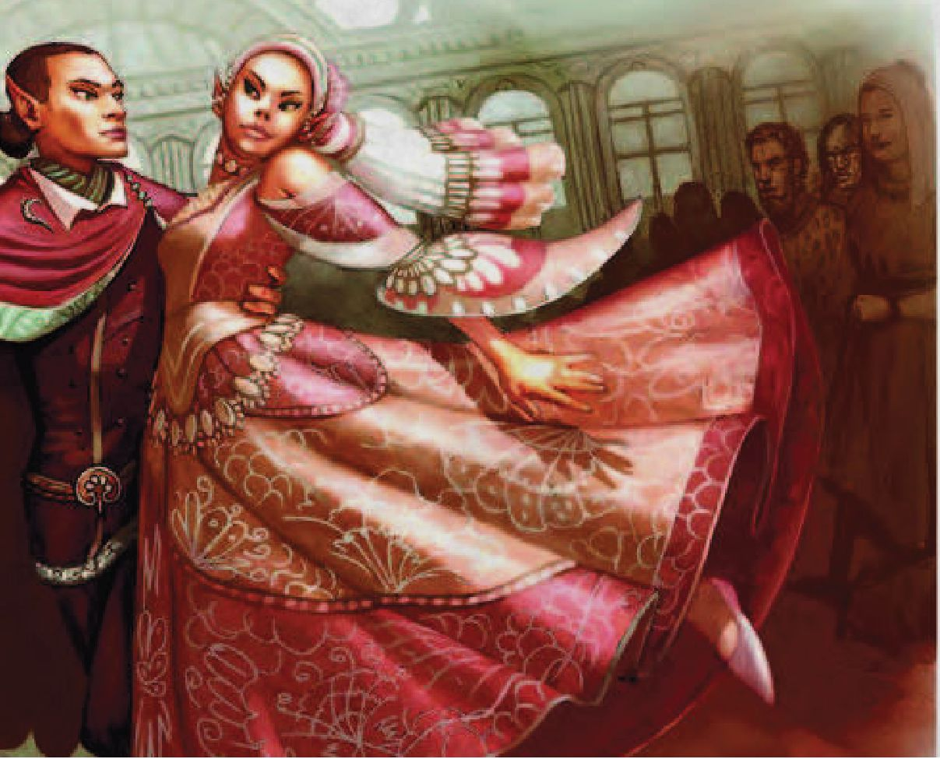

***What the characters can do.*** The table below presents some possible side-quests for this event.

Political Plot Event

d6 Side-Quests

1. Foreign agents are involved in the plot. The characters must arrest them without creating a war
2. The characters are hired to find all the conspirators
3. One of the conspirators is innocent and the characters must prove their innocence
4. Rebellion arises after the harsh reaction of the ruler. The characters can join either side
5. The characters are falsely accused of being a part of the plot*
6. The plot is a fraud. The characters must demonstrate this to the ruler to prevent further bloodshed

Might include a rival, as described in the *Xanathar’s Guide to Everything. \**

Rebellion

Factions within the realm attempt to overthrow the government of the realm. The exact strength of the rebellion is up to the DM. The tables below suggest some suitable groups for a rebellion and their motivations.

Rebel Groups

d6 Groups

1. Nobles
2. Peasants
3. Military
4. A church
5. A secret society
6. Guilds

Reason of Rebellion

d6 Reasons

1. To gain independence from the realm
2. Taxes are too high
3. To obtain privileges or rights
4. To overthrow the current government
5. Treatment is too brutal
6. Ally of an enemy realm

***What the characters can do.*** The characters can join the rebellion or be part of the loyalist forces.

Religious Matter

Something causes turmoil in one of the realm’s main faiths or a new religion arises inside its borders. The table below gives you some examples

Religious Matter

d6 Matters

1. A heresy of the orthodox creed is taking place

d6 Matters

1. The high priest of a church declares a holy war
2. A prophet is preaching against the hierarchy of the church
3. A dark cult is rotting from inside a faith
4. A sacred belief of the faith is shown to be a hoax
5. Some high temple members committed heinous acts

d6 Creature

1. Powerful spellcaster
2. Chosen of a god
3. Avatar of a god
4. Ruler in exile

***What the characters can do.*** The table below presents some possible side-quests for this event.

***What the characters can do.*** The characters may find themselves forced to choose between one side or the other, especially if one of them is a member of the religion.

2 The characters are sent as ambassadors to the creature

4 The characters are hired to steal a magic item owned by the creature

6 The creature is not welcomed by the government or religious authorities. The characters are asked to remove it

***What the characters can do.*** The characters can guard the affected areas from monsters and bandits until law is restored there. They can also investigate if the eruption was natural or supernatural.

5 The creature is looking for companions for its next quest

3 The characters discover that the creature is secretly a member of a dark cult

1 The creature has clues about the characters’ current quest

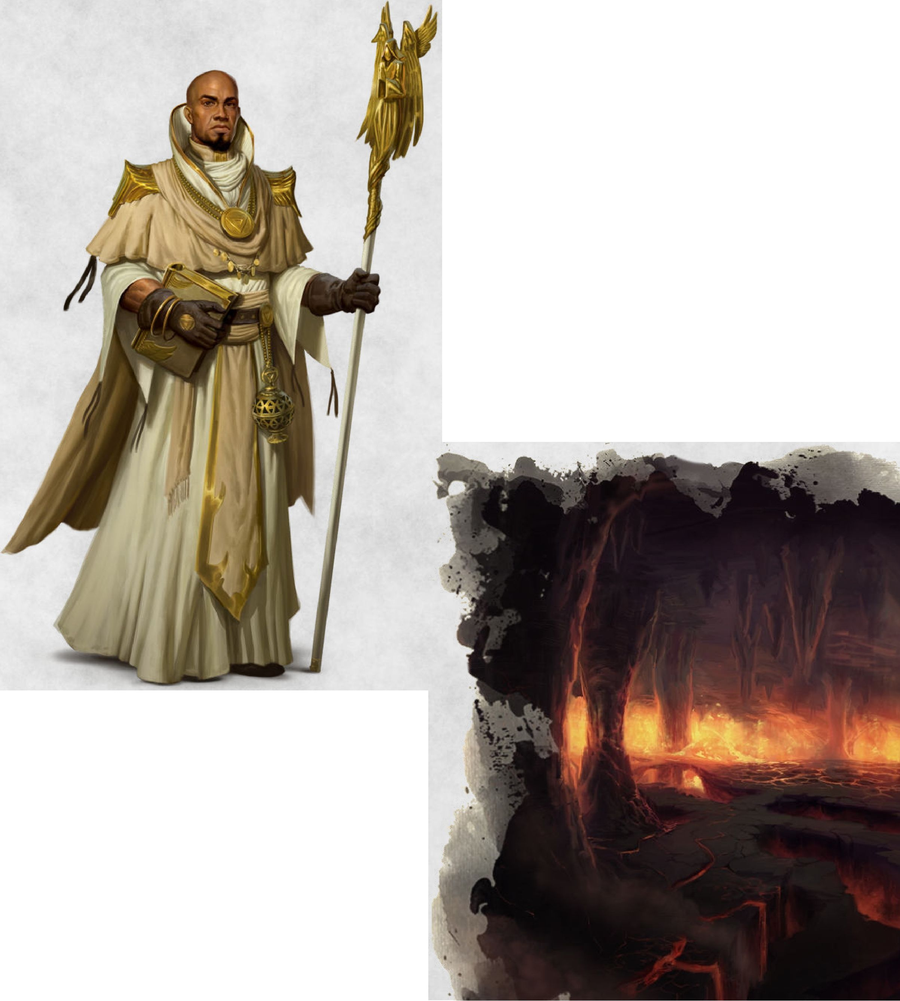

1. Celestial
2. Legendary hero

Visitation

A very special creature appears in the realm. News of its appearance spread fast and people come from all around to see it, or after it has left, visit the place where it resided The following table gives you examples of special creatures

Special Creature

d6 Creature

Visitation Event

d6 Side-Quests

Volcano

Either a dormant volcano erupts or a new one appears. When the eruption occurs, it is of exceptional violence. Everything within a 5-mile-radius is destroyed and ash rains down out to 30 miles. The volcano spews ash and smoke for ld4 months.

War

Either the realm launches a campaign against another realm, or it is invaded by hostile forces. The following table gives you some ideas for the reason of the war.

Reason of War

d6 Reasons

1. Desire to expand the realm
2. To gain control of important natural resources
3. To gain control of important magical assets
4. To define their borders
5. The two realms had two different beliefs which are tragically incompatible
6. There isn't an apparent reason. The two realms have been fighting for centuries

***What the characters can do.*** The characters can join one of the two sides or could try to restore peace between them. Alternatively, they could focus on protecting commoners from the harsher effects of the war. In the table below are presented some possible side-quests for this event.

War Event

d6 Side-Quests

1. The army enlists the characters
2. The characters are appointed as commanders of a military unit, or maybe the entire army of the realm
3. The characters are hired to sabotage behind the enemy lines
4. The characters must secure or protect an important person, magic item, or treasure
5. The enemy army seems to have a special weapon. The characters must locate it and steal or destroy it
6. The characters are sent as envoys to start peace talks or to find new allies

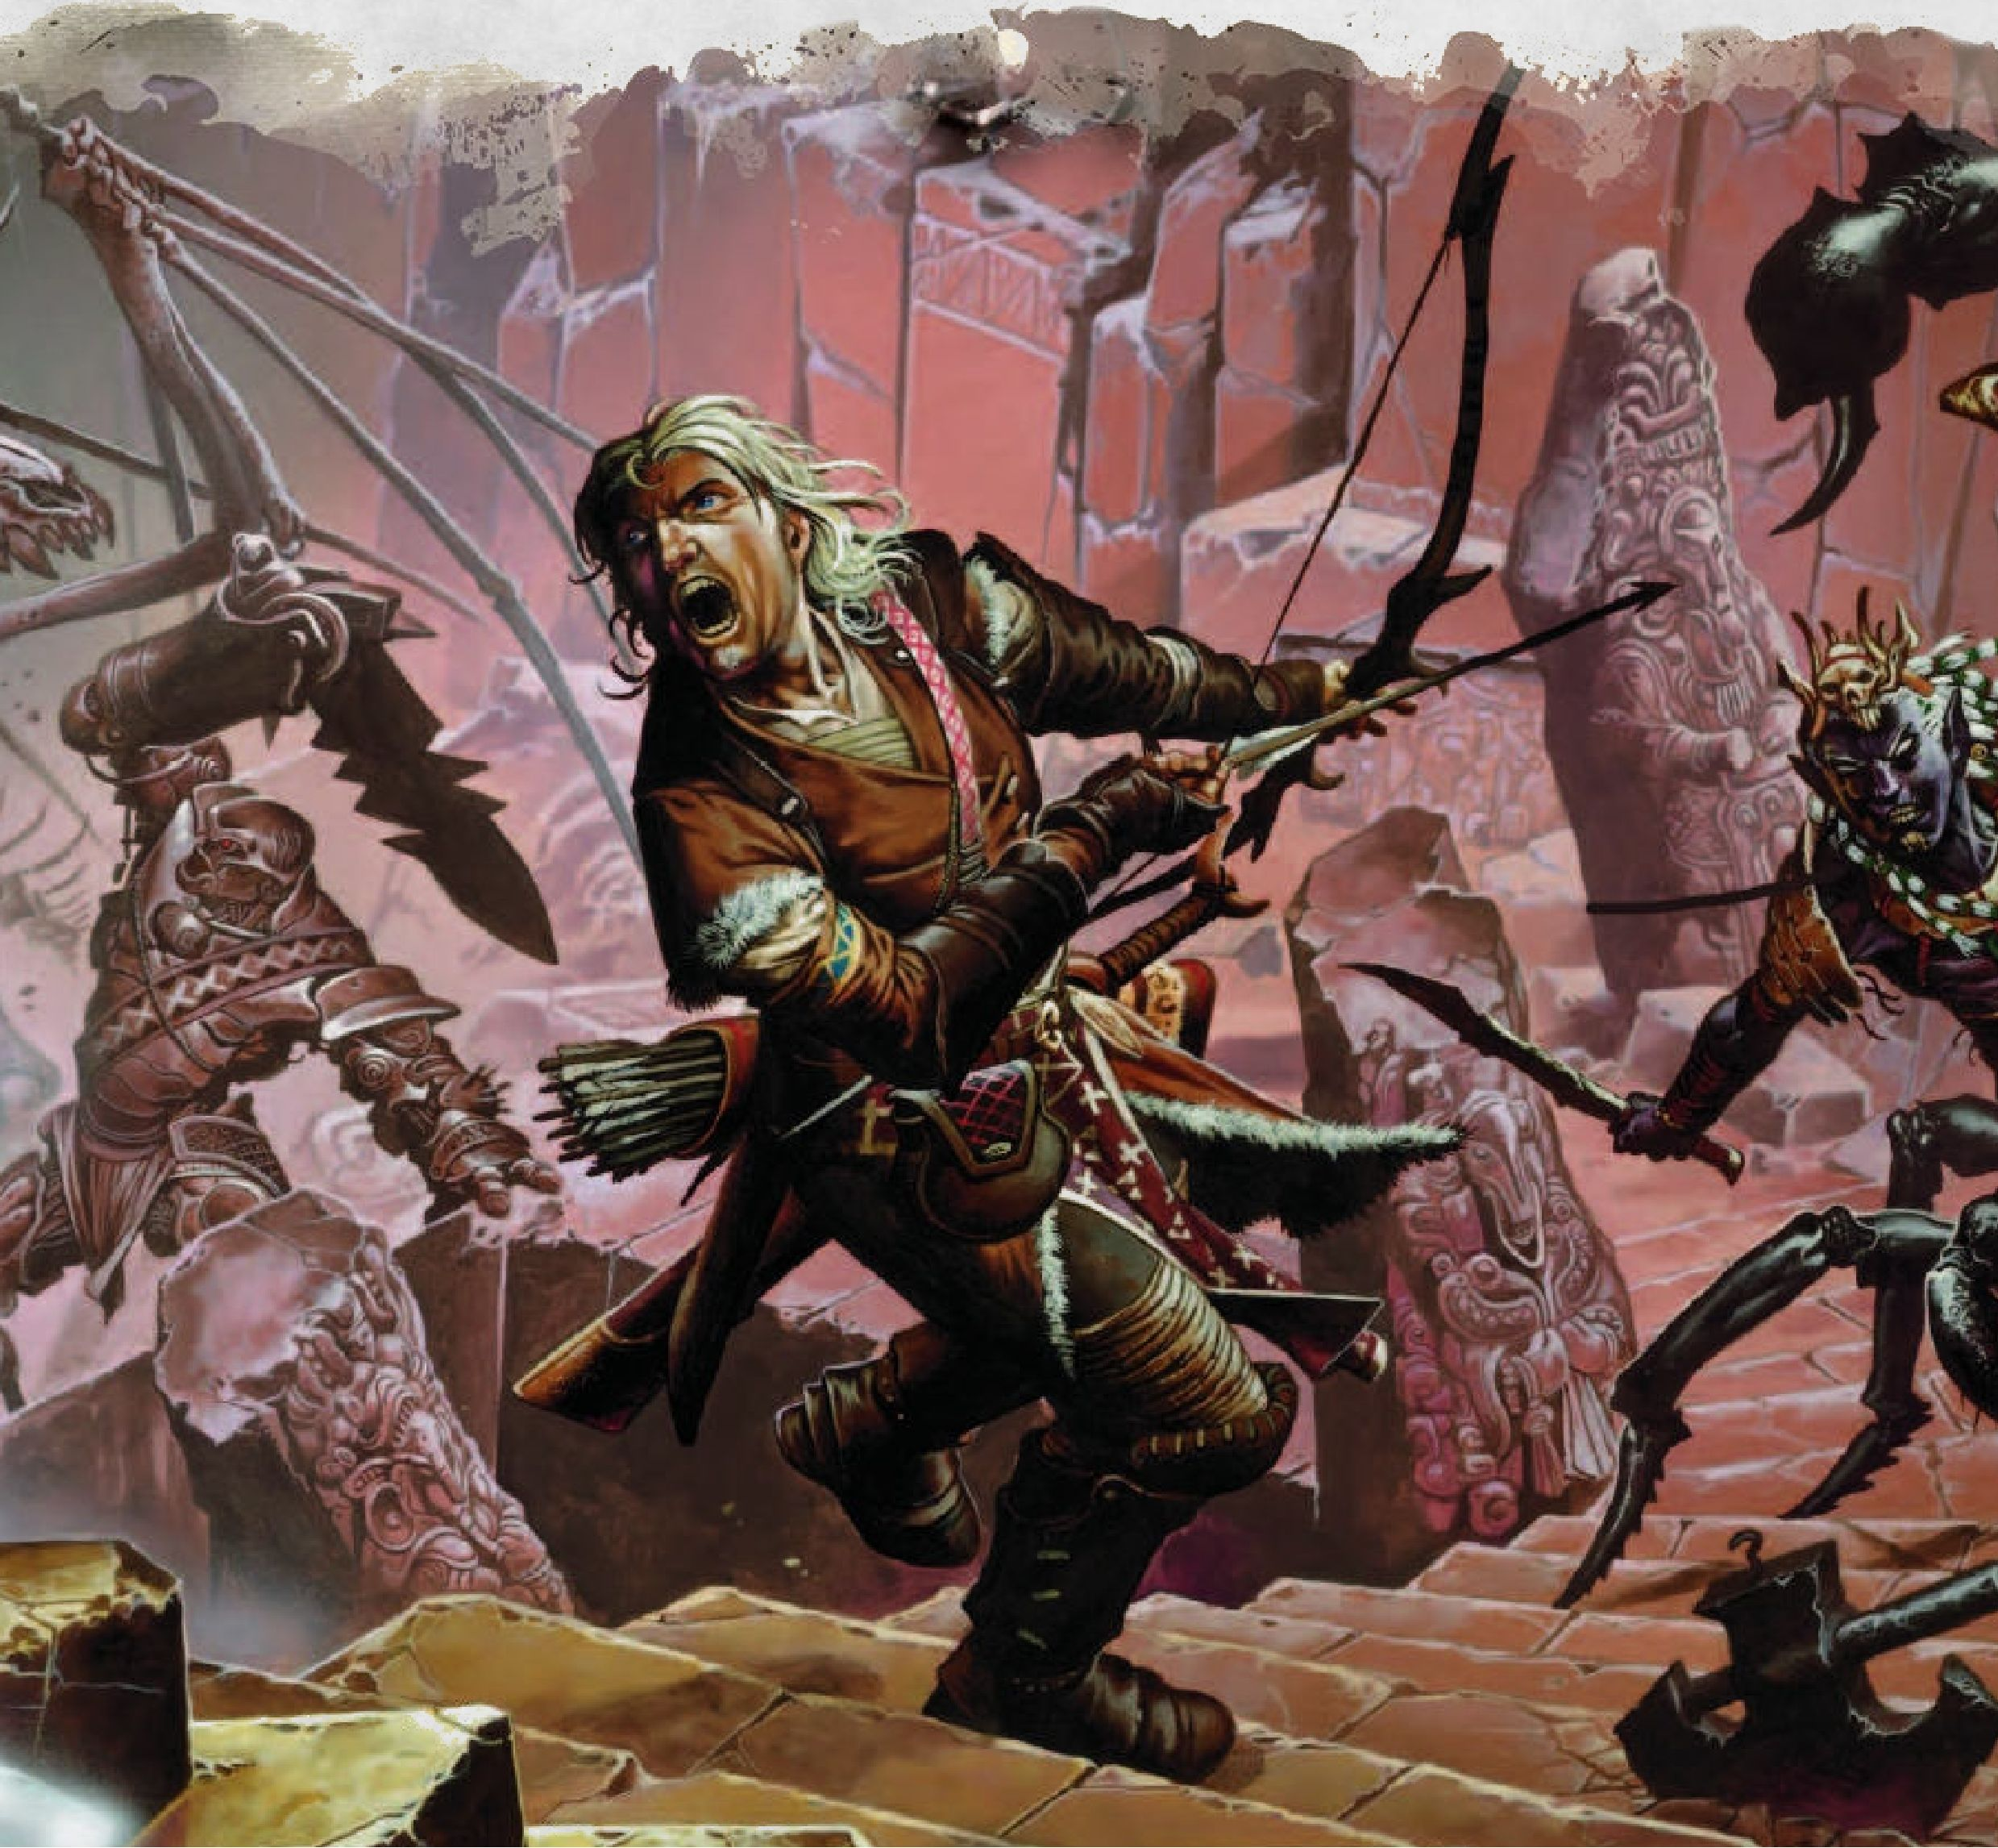

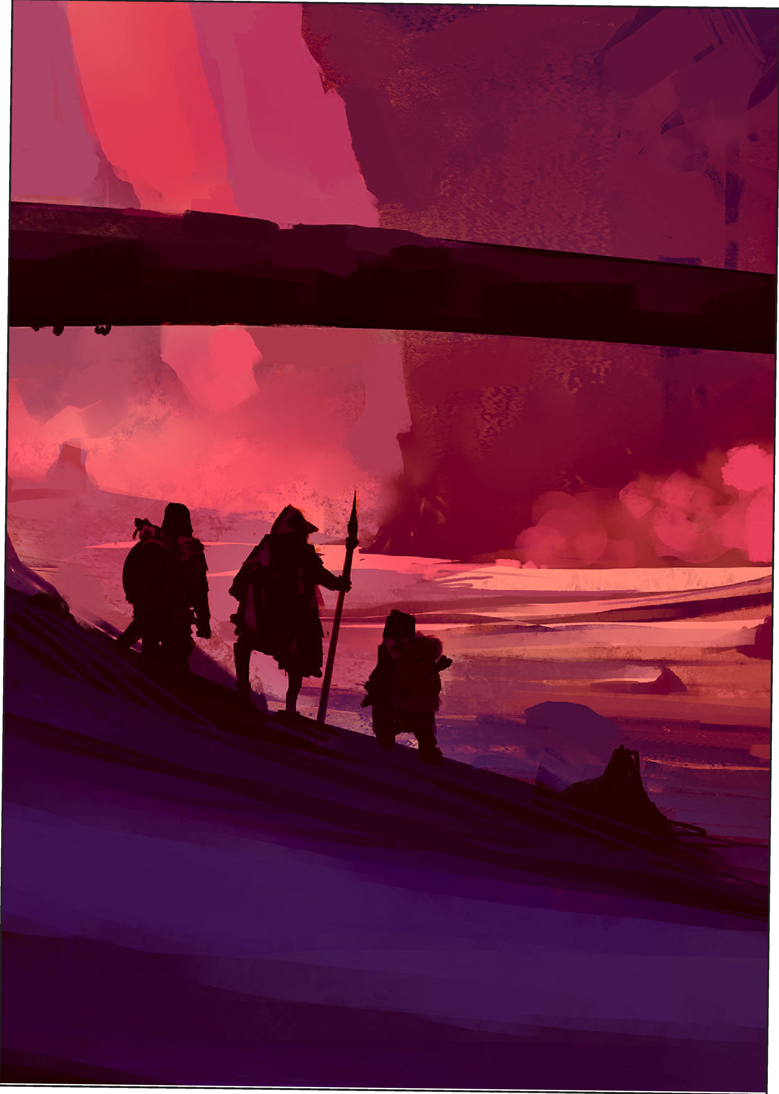

Chapter 3: How to Use the Events

he following topics will help the DM use ' Realm Events

New NPCs and Plots

Many of the events described in the previous chapters are useful means to introduce to new NPCS, plot points, or quests.



Generally, you should use the local events every time the

characters arrive in a settlement or every couple of months they spend in that place. Regional events should occur no more than twice a year.

Alternatively, determine event frequency by rolling a dlOO and consult the following.

Monthly Events

d100 Result

01-70 No event

71 -00 Roll on the local event table in Chapter 1

Monthly Regional Events

d100 Result

01-90 No event

91-00 Roll on the regional event table in Chapter 2

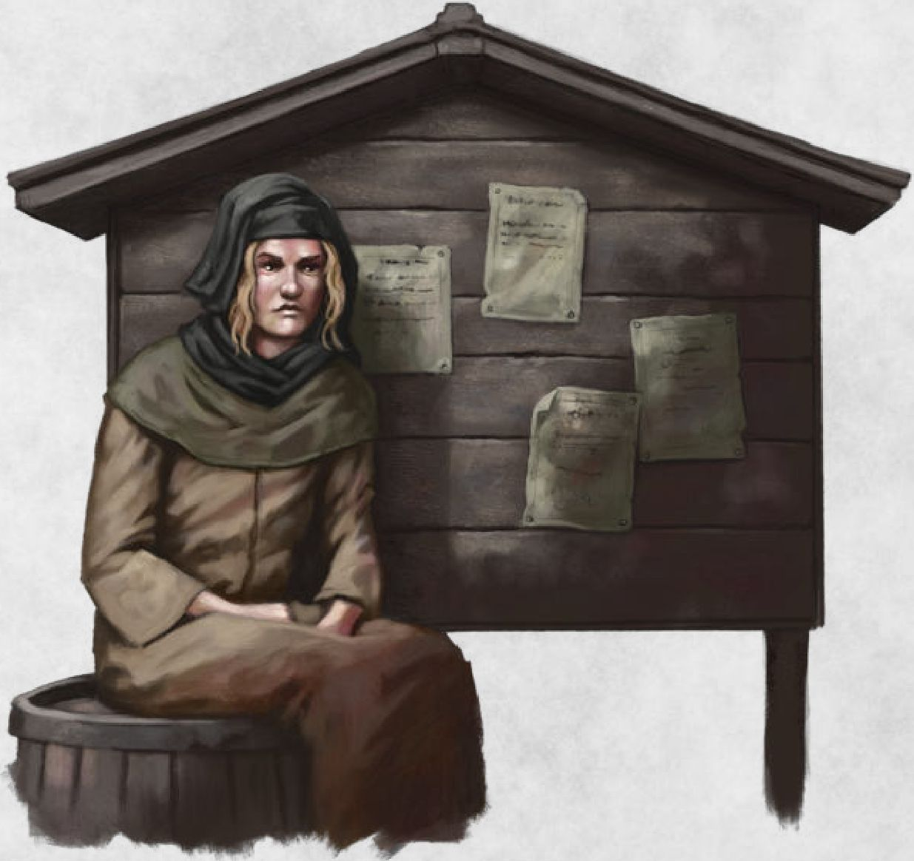

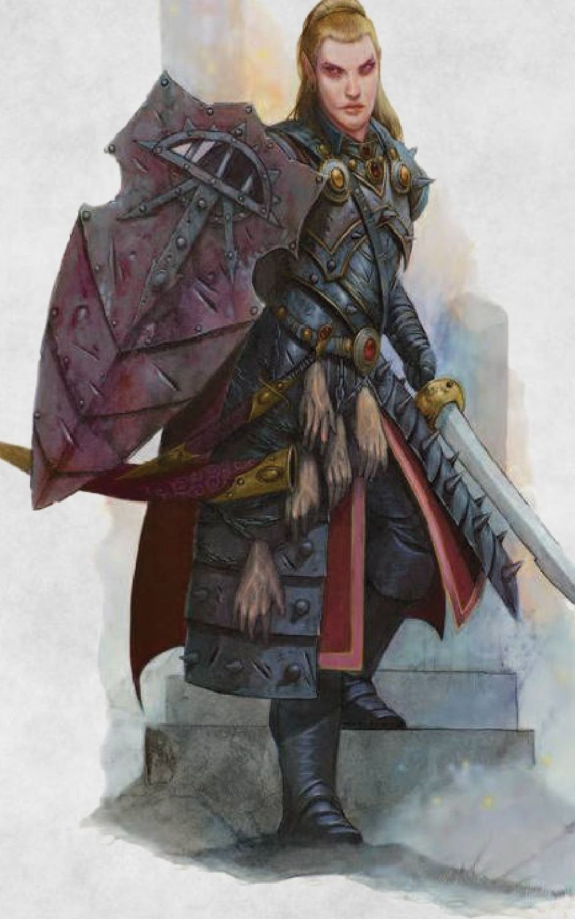



CHAPTER 3 | HOW TO USE THE EVENTS